**ThenThrow()**

* S-ar putea sa avem nevoie sa cream un Mock ce sa arunce o exceptie pentru a vedea cum codul nostru gestioneaza exceptiile
* Tot ce trebuie sa modificam thenReturn in **thenThrow**
* 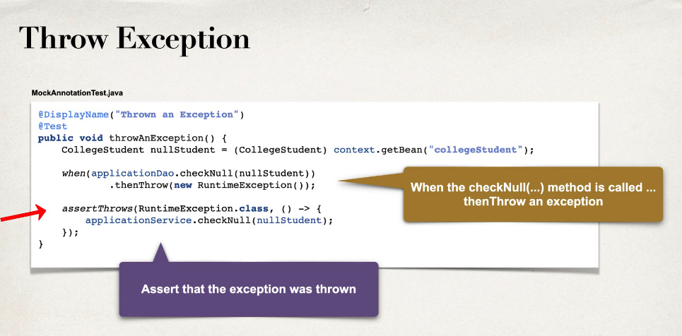

**Consecutive call**

* Putem face asa ca daca metoda e executata de mai multe ori, sa se comporte diferit de prima apelare
* De ex, putem face ca prima data cand e executata, sa arunce o exceptie, apoi a 2 oara si a 3 si a 100 oara cand e executata, sa arunce vreun String
* Facem asa **when().thenThrow().thenReturn()**

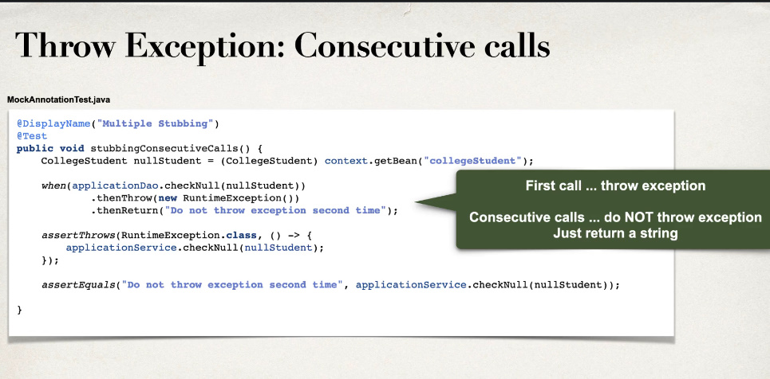

deci, doar prima data la executarea ei, e va arunca o exceptie, mai departe deja doar string

@DisplayName("Multiple calls")  
@Test  
public void ConsecutiveCall(){  
 CollegeStudent collegeStudent = (CollegeStudent) applicationContext.getBean("collegeStudent");  
 *when*(applicationDao.checkNull(collegeStudent)).thenThrow(new RuntimeException("Opaa")).thenReturn("Test String");  
  
 *assertThrows*(RuntimeException.class,()->applicationDao.checkNull(collegeStudent));  
  
 *assertEquals*("Test String",applicationDao.checkNull(collegeStudent));  
  
}

* Putem folosi si
* **doReturn(Obj).doThrow(new Exception).when(object).metoda()**

@DisplayName("Multiple calls")  
@Test  
public void ConsecutiveCall(){  
 CollegeStudent collegeStudent = (CollegeStudent) applicationContext.getBean("collegeStudent");  
 *doThrow*(new RuntimeException("Opaa")).doReturn("Test String").when(applicationDao).checkNull(collegeStudent);  
  
 *assertThrows*(RuntimeException.class,()->applicationDao.checkNull(collegeStudent));  
  
 *assertEquals*("Test String",applicationDao.checkNull(collegeStudent));  
  
}

**doReturn and doThrow**

* doReturn = thenReturn
* doThrow = thenThrow
* **Aceste 2 metode sunt echivalente cu celelalte 2 deja folosite**. Totusi, doReturn si doThrow se folosesc putin diferit:

**doReturn**

when(object.metoda()).thenReturn(response)

doReturn(response).when(object).metoda()

**Atentie unde e .metoda()**

Seamana forma ca la verify()

**doThrow**

when(object.metoda()).thenThrow(new Exception())

doThrow(new Exception).when(object).metoda();

@DisplayName("Throw runtime exception")  
@Test  
public void throwRunTimeError(){  
 CollegeStudent collegeStudent = (CollegeStudent) applicationContext.getBean("collegeStudent");  
 *doThrow*(new RuntimeException("Test")).when(applicationDao).checkNull(collegeStudent);  
  
 *assertThrows*(RuntimeException.class,()->applicationDao.checkNull(collegeStudent));  
 *verify*(applicationDao,*times*(1)).checkNull(collegeStudent);  
}